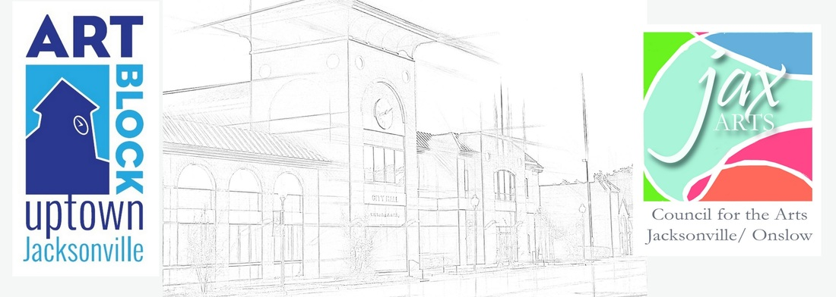
Art Block Paint Out Registration Fees (Rain or Shine):
Registration form must be completed and returned along with fee to be eligible for competition. All fees are non-refundable. Rain or shine.
Pre-Register until March 15th before 5pm: $25
Late Register from March 16th – Day of event: $30
Art Block Plein Art Paint Out Registration Form:
Artist Name: ___________________________
E-mail Address: _________
Address_________________________________________________________________________________________________________________________________________________
Home/Cell (Circle One): ________________________
I am a ___ Member of JaxArts ___ Non-Member
___EXPIRED___ I am registering for the Art Block Paint Out on April 14, 15, and 16, 2016 at the pre-register rate of $25 (post marked before March 15, 2015.
______ I am registering for the Art Block Paint Out on April 14, 15, and 16, 2016 at the late register rate of $30 from March 16th – Day of event.
Payment Information- I am paying by ______ Cash ______ Check _______ Credit Card
Credit Card Number: ________
Expiration Date: ____________________
Billing Zip Code: ____ 3 Digit Code: _
Signature: ________________________
Return Registration Form (page one only) and Fees to:
Council for the Arts, 826 New Bridge Street, Jacksonville, North Carolina 28540

Plein Air Paint Out on April 14, 15, & 16, 2016
Artists will paint local public and private sites in beautiful Historic Uptown Jacksonville, North Carolina. Painting boundary includes many picturesque scenes including the Pelletier House along the banks of the New River, the USO, the old Jacksonville Train Depot, the City Hall Tower, the Freedom Fountain, beautiful Wilson Bay, the Beirut, WWII, Vietnam, and 911 Memorials. The Art Block Plein Air Paint Out is sponsored by the JaxArts Council for the Arts and will feature a judged competition with prizes, a wet-sale during the Art Block street festival, and a month long exhibit in the Jean Wenner Gallery at the Council.
Rules: Artists may submit up to 3 pieces for judging. All works must be done en plein air (outside), during the event, within the boundaries confirmed on map, and without the assistance of photographs. All canvases must be stamped at registration and must be turned in at the end of the day on Saturday (see schedule). All media are accepted except for photography. Brenda Behr will be this year’s judge. Brenda is well know throughout the state in all art circles and is an accomplished artist and instructor.
Canvas Restrictions: Canvases/Substrates may be no larger than 36 inches in any direction. Artists may submit up to 3 completed works for judging. All canvases must be stamped at registration.
Sales: Completed works may be listed for sale at the wet-paint sale and during the exhibit. The wet-paint sale will begin immediately after the judging on Saturday afternoon, April 18th during Art Block. JaxArts retains 25% commission. Works will be displayed at the Jean Wenner Gallery at the Council from April 18 through May 20 (unless sold). Artists must price their own pieces: JaxArts is unable to price pieces for artists.
Awards: 1st Place: $200 2nd Place: $150 3rd Place: $100
Critique: Brenda Behr will give critiques after judging for artists requesting one.
Schedule (Rain or Shine): *Indicates Painting Days
Nocturnal paintings accepted.
*Thursday, April 14th
10:00 am - Artist registration and canvas check-in at the JaxArts aka Council for the Arts, 826 New Bridge Street, Jacksonville, North Carolina 28540. Artists are given packet and painting boundary map. Artists begin painting.
*Friday, April 15th
8:00am – 10:00am – Registration at JaxArts for artists just arriving. Canvases stamped. Artists continue painting.
6:00 - 9:00 pm - Art Block Evening Reception for artists... Location and Entertainment TBA.
*Saturday, April 16th
8:00am – 10:00am – Registration at JaxArts for artists just arriving. Canvases stamped. Artists continue painting.
10:00am – 4:00pm – Art Block Festival
2:30pm – 3:00pm - Artists return to JaxArts and submit final works for judging
3:00pm – 4:00pm – Judging, Awards, and Wet-Paint Sale
April 18 through May 20
Works on display/for sale at Jean Wenner Studio at JaxArts.
May 20 – 27, 2016.
Artists pick up unsold work from JaxArts during regular studio hours.

Council for the Arts, 826 New Bridge Street, Jacksonville, North Carolina 28540
Phone: 910 455-9840
Website: www.jaxarts.com
Email: jaxarts@jaxarts.com

