Scott Boyle
Plein Air Workshop
Friday, April 17, 2015
Jacksonville, NC
Council for the Arts Jacksonville/Onslow

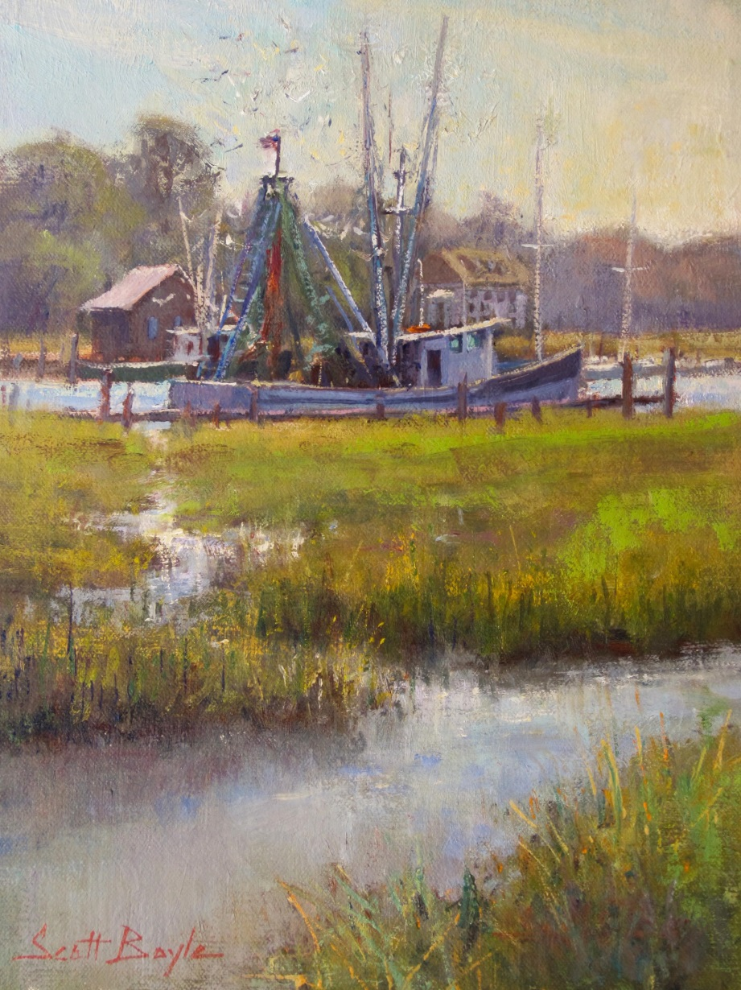

“Feeding Time” 12 x 9 oil plein air by Scott Boyle

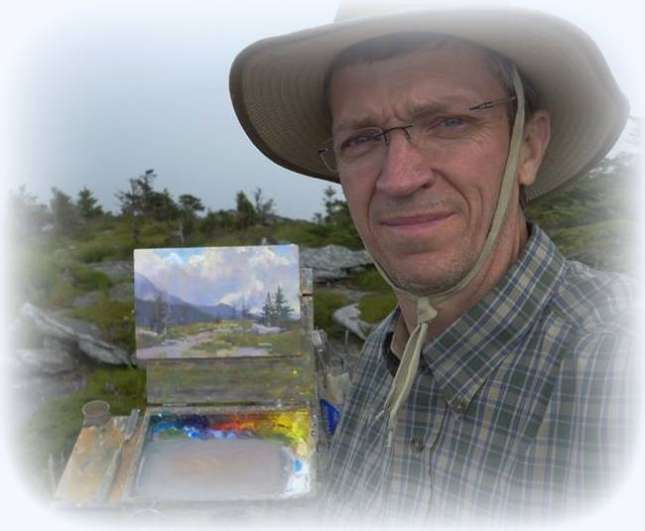
Scott Boyle 1 Day Plein Air Workshop
Friday April 17, 2015

Discussion Topics

• Lighten your load – efficient outdoor painting equipment
• How to select a scene to paint outdoors
• How to simplify complicated subjects
• Advantages to limiting your palette
• Understanding our limitations when working outdoors
• Discovering the joy of plein air painting

Schedule
9:00am – 4:00pm
Scott will demo in the morning followed by student painting after lunch.

Class size - 10 students

Cost - $30

North Carolina landscape artist Scott Boyle is a visual explorer, a promoter of plein air painting, and the founder of the North Carolina Plein Air Painters, which organizes numerous outdoor painting events around the state each year. Additionally, he teaches workshops and frequently speaks on subjects relating to outdoor painting.

Scott specializes in oils though all mediums are welcomed.

Artist’s website – www.scottboyleart.com

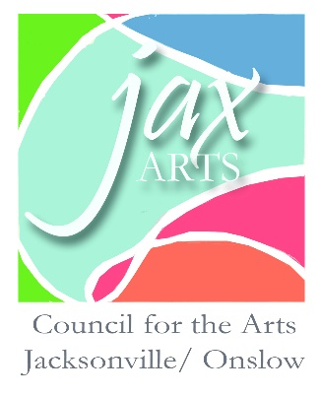

To Reserve your place please contact:

Connie Wenner
Exe. Director Council for the Arts
Location: 826 New Bridge Street Jacksonville, NC 28540
Phone: 910 455-9840 Monday - Friday 8:30am - 4:30pm
web -www.jaxarts.com
email - jaxarts@jaxarts.com

